- What is the maximum size of the address space generated in a processor with has 32 bit
address?

The maximum size of the address space generated in a processor with has 32 bit address = 2³² = 4 Giga Locations.

- a) How many 128 x 8 RAM chips are needed to provide a memory capacity of 2048 byte?
b) How many lines of the address bus must be used to access 2048 bytes of memory? How many of these lines will be common to all chips?
c) Specify the size of the decoders.

a) 128 x 8 RAM => 128 Bytes (8bits) / chip => Number of chips = 2048 / 128 = 16
b)2048 = 2^{d}, where d is number of address lines => d = 11
We have 16 chips => 4 bits for chip select Number of common address lines is 11 - 4 = 7 Summary: 4 bits (MSB) to select the correct chip and 7 bits (LSB) to select the memory location inside the selected chip.
c)We need 4 x 16-line decoder

3..1) if a computer uses RAM chips of 1024 x 1 capacity, how many chips are needed to provide a memory capacity of 1024 byte?
3.2) How many chips are needed to provide a memory capacity of 16K bytes?

d.1) Memory size is 1024 bytes = 8 x 1024 x 1 RAM => 8 chips
d.2) 16K bytes = 16 x 1024 x 8 => 128 chips.
How many 256 X 4 RAM chips are required to organize a memory of capacity 32KB ? What is the size of decoder required in this implementation to select a row of chip?
target size = 32KB = 32K x 8 (1 Byte = 8 bits) = 2¹⁵ x 8 bits
basic size = 256 x 4 = 2⁸ x 4 bits
No of chips = target size/ basic size = 2⁷ x 2 = 256
Size of decoder can be calculated from the row chips of basic size = 8 x 2⁸ = 8 x 256

Or if
And for byte (8 bits) we need 2 chips in row
Total no of rows =128
So 7 X 128 decoder is required to select a row

- You have RAMs 128 X8 and ROM 512 X 8. You need to make RAM of 512 X 8 RAM. Design memory organisation for the given scenario. What can be the total memory accessed in this organization.

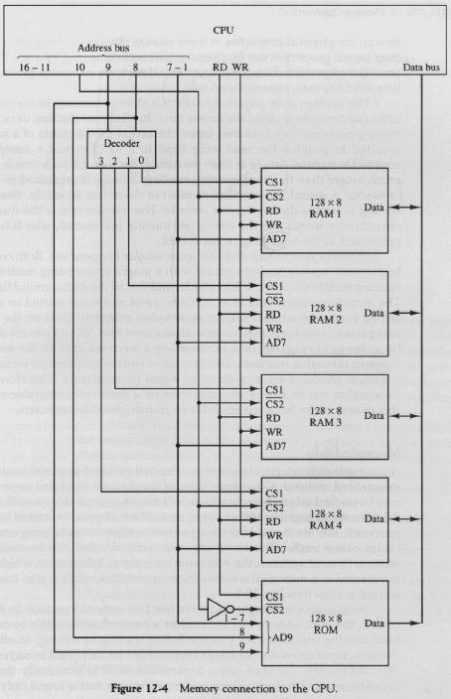
ram-and-rom-chips-130126022718-phpapp02.pdf
An application program in a computer with cache uses 1400 instruction fetch from
cache and 100 from main memory. What is hit ratio?
Hit Ratio = No. of Instruction fetch from cache / Total no. of instructions
= 1400 / 1500 = 93.333%

- Consider a two level cache with access time 5 nsec and 80 nsec respectively. If the hit
ratio are 95% and 75% respectively in the two caches and main memory access time is
250 nsec. What is the effective access time? (effective access time =H1T1+H2(1-H1)T2+…….
Access Time = H1T1 + H2 (1 – H1)T2 + (1 – H1)(1 – H2)T3
= .95(5) + (1 - .95).75 X 80 +(1-.95) (1-.75)250
= 4.75 + 3.00 + 3.125 = 10.875 nsec

- Let’s say that we have two levels of cache, backed by DRAM:
- L1 cache costs 1 cycle to access and has miss rate of 10%
- L2 cache costs 10 cycles to access and has miss rate of 2%
- DRAM costs 80 cycles to access (and has miss rate of 0%)
Then what would be average memory access time (AMAT)?
0.90 * 1 + | probability hit in L1 cache * time to access L1
0.10 * | probability miss in L1 cache *
0.98 * (10 + 1) | probability hit in L2 cache * time to access L1 then L2
0.10 * | probability miss in L1 cache *
0.02 * | probability miss in L2 cache *
(1 + 10 + 80) | time to access L1 then L2 then DRAM
= 2.16 cycles

